Shabbos Stories for
Parshas Beraishis 5777
Volume 8, Issue 6 27 Tishrei 5777/ October 29, 2016
Printed L’illuy nishmas Nechama bas R’ Noach, a”h

For a free subscription, please forward your request to keren18@juno.com
The Secular WSJ Columnist Who Inspired the
Worldwide Shabbos Project
By Allison Josephs

The Shabbos Project: an initiative which began in South Africa a year and a half ago and aims to encourage every Jew in the world observe one Shabbos together, has gotten quite a bit of buzz.
But how did it all begin? Not how you’d expect! Dan Ariely – a behavioral psychologist whose Wall Street Journal column (“Ask Ariely”) I read regularly – was the man behind the plan.
Ariely, a secular Israeli, had a question a few years ago: if a Jew were to keep one mitzvah and one mitzvah only, which would be the most impactful? He asked the chief rabbi of South Africa as well as the chief rabbi of England. Both rabbis independently gave him the same answer: Shabbos.
Why? Because the act of keeping Shabbos is so powerful, they explained, that its inspiration would trickle into others areas of life. Our sages teach that “mitzvah goreres mitzvah” – the one commandment leads to another, but the rabbis felt this was especially true for Shabbos.
Dan wanted to test this hypothesis so he approached the chief rabbi of South Africa, Warren Goldstein, with a proposal. What would happen, he wondered, if they got all the Jews in the country (which has a pretty traditional Jewish community) to keep one Shabbos together. This conversation with Ariely is what inspired Rabbi Goldstein to roll out the “one Shabbat” concept.
The project itself was devised and brought into existence by Rabbi Goldstein and in the end, had over 90% participation and the feedback was astounding – numerous lives were changed in meaningful ways. This year, in honor of The Shabbos Project, which takes place this Shabbos – October 23-24 – I thought it would be nice to hear from a couple of people who were impacted by ‘The Shabbos Project social experiment’.
Yakir Fraiser, a sixteen year old high school student from Melbourne, is the first participant I spoke to. He was raised in a traditional Jewish home, but he never spent a fully observant Shabbos until The Shabbos Project. Before his first full Shabbos experience, Yakir always expected that twenty-five hours unplugged would be boring. He has never been one to just sit around and do nothing and figured that nothing was all one did on Shabbos. In the end, he decided to give it a try because it was just “one day,” and if it was insufferable, it would be over before he knew it.
Much to his surprise, Yakir discovered something fascinating over those twenty-five hours – Shabbos is truly enjoyable. The exact opposite of what he thought! Over the course of the Shabbos, Yakir made a friend from Sydney who was “so normal” despite being religious. This friend, Eliyahu, recognized a passion in Yakir and told him about a Jewish school in Melbourne called Yeshiva College. Eliyahu suggested he check it out.
While Yakir did feel differently after that initial Shabbos he did not make any immediate changes nor did he look into the yeshiva. He simply returned to life as usual. But then, one day – he doesn’t even remember why or how – Yakir found himself on the Yeshiva College website. Before he knew it he was e-mailing them, taking entrance exams and then moving across the country to Melbourne to board with a family there.
The family Yakir moved in with was not religious, which Yakir chose purposely, so that he could grow slowly in his observance. This past summer, though, he moved in with a religious family as Yakir is now fully observant. Yakir had never heard that The Shabbos Project was started as a social experiment to test the impactfulness of Shabbos on a Jew. “Did it work?” I asked him. Apparently!
I spoke to another person whose first Shabbos also took place during The Shabbos Project. He also experienced life-changing but different results. Robby Nissan is a father of two who lives in Israel and headed up The Shabbos Project there. He explained that in Israel there are a lot of secular Jews who love the traditions – lighting candles, family meals, but struggle with the religious aspects of Judaism because they grew up with bad memories of having rocks thrown at their cars when driving on Shabbos, or religious people yelling to keep Shabbos. (I explained to him that we speak out against that kind of extremism at Jew in the City.)
His family spent The Shabbos Project weekend with a group in a hotel in Jerusalem which was amazing. Dinner took much longer than usual and after dinner there were stories and singing. By the time they were done it was time for bed. The next day they woke up and after shul they played with the kids, went to lunch, took a walk, took a nap – and then it was over. It was perfect.
Robby explained that Shabbos is a great opportunity for adults to relive their childhoods and show their children the games they grew up with. His sons, nine and seven years old, became fascinated by how much fun you can have without devices and how happy you can be with so little – something too few kids grasp these days.
Since The Shabbos project, Robby does not watch TV on Shabbos anymore. It used to be the binge-watching day for him and his wife, but he’d rather be unplugged. He also no longer looks at his cell phone on Shabbos unless it’s an emergency. Robby appreciates the gift of the “pause” in his life and the opportunity to spend time with his family. He still drives and is unsure if he will take on anything else at the moment – but he is so grateful for all that he has taken with him from The Shabbos Project.
Well, Mr. Ariely, your experiment seems to have impacted countless Jews around the globe since its inception. I can’t wait to hear more stories of new lives touched on this year’s Shabbos Project.
Reprinted from the October 20, 2015 website of Jewinthecity.com This year’s global Shabbat Project will be celebrated on Parshas Lech Lecha, Nov. 11-12.
World’s Oldest Man, After
Century Wait, Celebrates
Bar Mitzvah at Last
By Dan Bilefsky
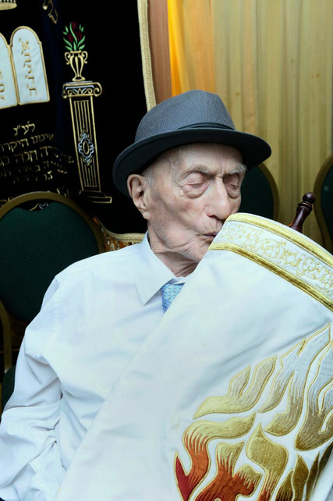
Yisrael Kristal, the world’s oldest man at 113, with a Torah in an undated photograph. Mr. Kristal lived through both World Wars and survived the Auschwitz concentration camp. Photo CreditKristal family, via Associated Press
Yisrael Kristal, like many a bar mitzvah boy before him, celebrated the event last weekend, reading the Torah and enjoying the company of his family, who danced, sang and threw candies.
But Mr. Kristal was surrounded at the ceremony in southern Israel by his two surviving children, nine grandchildren and 30 great-grandchildren. He is 113, and he had to wait a century to mark the occasion.
“My father is a religious man, and it was his dream his whole life to have a bar mitzvah,” his daughter Shulamith Kristal Kuperstoch said by telephone from her home in Haifa, Israel. “It was a miracle after everything that he has been through in his life. What else can you call it?”
When Allied troops liberated Auschwitz in 1945, she said, Mr. Kristal weighed 82 pounds. He was the only member of his family to survive the Holocaust.
She said her father had smiled widely after the bar mitzvah, which celebrates the moment when a boy can participate fully in Jewish life and traditions, including being allowed to be called in religious ceremonies to read from the Torah, the first five books of the Old Testament.
Mr. Kristal was born Izrael Icek Krysztal in the village of Malenie, in what is now Poland, on Sept. 15, 1903. When he was 11, Franz Joseph, the emperor of Austria-Hungary, passed through his town. The boy threw sweets at the emperor, perhaps presaging Izrael’s career in the chocolate and candy business.
By his 13th birthday, World War I was raging and he missed his bar mitzvah, Ms. Kristal Kuperstoch said. His father was in the Russian Army, and his mother had died three years earlier. By age 16, after his father had died of typhus, he was an orphan.
After the war, he opened a candy store in the Polish city of Lodz with an uncle and prospered. But after Germany invaded Poland in 1939, Mr. Kristal, his wife and their two children were moved to the ghetto in Lodz, where the children died.
In August 1944, he and his wife were sent to Auschwitz, where his wife was killed.
After the war, he returned to Lodz, remarried, and in 1950 he moved to Haifa with his second wife and their son. He rebuilt his life, again becoming a successful confectioner.
In March, at the age of 112 years and 178 days, he was declared the oldest man in the world by Guinness World Records.
Ms. Kristal Kuperstoch said her father had prayed every morning for the past 100 years. She attributed his longevity to “the above.”
“He believes in G-d,” she said. “He is a simple man, a wise and intelligent man. He believes in himself. He is someone who takes happiness in everything.”
She said part of his secret for getting to age 113 was “eating to live rather than living to eat.” When he does eat, Ms. Kristal Kuperstoch added, he enjoys daily helpings of pickled herring and, as a younger man in his 80s, had a taste for wine and beer.
He lives in his own home with a housekeeper. He remains sharp and still likes speaking Yiddish and listening to Yiddish songs, Ms. Kristal Kuperstoch said.
“He wakes up early each morning, catches up on the news and eats a simple breakfast,” she said. “He is interested in politics and used to read the newspaper every day. Now I read it to him since his eyesight is failing.”
Mr. Kristal’s granddaughter Liat Bashan, a 32-year-old social worker, said that seeing her grandfather at his bar mitzvah ceremony, in a room spilling over with relatives and loved ones, had left her overcome with joy — and mindful of all those who perished in the Holocaust.
“All those people from one person,” she said. “Imagine how many rooms could be filled if six million had lived.”
She added: “Every time I see my grandfather, I want to make a blessing.”

Reprinted from the October 6, 2016 website of The New York Times. A version of this article appears in print on October 7, 2016, on page A8 of the New York edition with the headline: Celebrating Bar Mitzvah after Century of Waiting.

The Unexpected Callous Attitude of the Torah Sage
By Rabbi N. Reich

A great sage was sitting in his room, immersed in a pile of holy books. Just then a distraught woman burst through the door and planted herself in front of him.
"You must help me!" she wailed as tears ran down her cheeks. "My husband is seriously ill."
"Come back tomorrow," said the sage.
"Tomorrow?" she shrieked. "I can't wait until tomorrow. He may be dead by tomorrow. I need your help now!”
"If you insist," said the sage. He closed his eyes and pursed his lips. After two minutes of silence, he opened his eyes. The woman looked at him with breathless expectation.
"I'm very sorry," he said. "I can do nothing for your husband."
The woman went deathly pale. She clutched her head and screamed, "Lord in Heaven! Help me! I am lost. Even the holy sage cannot help me. Only You can save my husband. Please! I beg of you!"
Then she collapsed into a chair, her body wracked by wrenching sobs.
"Go home in peace, my child," said the sage. "Your prayers will be answered. As long as you placed your trust in me, there was no hope. But the hopelessness in your heart led you to our Father in Heaven. He is the only One who can give you what you need."
In our own lives, as we strive for financial and professional achievement, how often do we think to ourselves that the key to success lies in contacts, marketing or other stratagems? But that is not really true. No matter how hard we work or plan or scheme, Hashem can wipe it all away with a flick of His figurative wrist.
So what are we supposed to do? Of course, we need to make our best efforts, to go after the contacts and the marketing and whatever else seems to be indicated. But we must always keep in mind that Hashem controls the world, and if we're looking for contacts, He is undoubtedly the Ultimate Contact.

Reprinted from the Parshas Ha’Azinu 5777 email of Shabbos Candle Lighting.

Dutch Survivor’s Diary Called an Anne Frank Story
With a ‘Happy’ Ending
By Cnaan Liphshiz

Unique tale is one of few to focus on religious life in hiding, while the family lived in close quarters with their Catholic saviors

AMSTERDAM (JTA) — A Holocaust survivor dubbed “Rotterdam’s Anne Frank” in her native Netherlands published her wartime diary, which she wrote while hiding in the bombed-out city.
“At Night I Dream of Peace,” the Dutch-language diary of 89-year-old Carry Ulreich, hit bookstores in the Netherlands last week. The book generated strong interest from the national media, which likened and contrasted Ulreich’s story with that of Frank, the murdered Jewish teenager from Amsterdam whose diaries in hiding were made into one of the world’s best-read books about the Holocaust.
Ulreich, who immigrated to Israel in the years after World War II, was two-and-a-half years older than Frank when the Nazis invaded the Netherlands in 1940 and sent many of the country’s 140,000 Jews into hiding. Unlike Frank, whose writings have been described as offering a universalist worldview, Ulreich displays a distinctly Jewish one, describing her deep emotional connection to Jewish prayer and traditions.

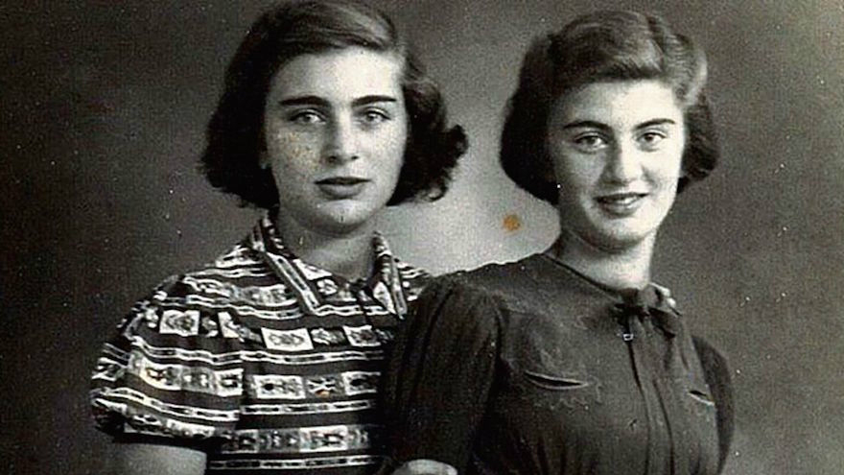
Carry Ulreich, right, and her older sister, Rachel, in a photograph taken during their time in hiding in Rotterdam during the Nazi occupation. (Boekencentrum/Mozaïek/JTA)

Whereas Frank and many of her relatives were among the 104,000 Dutch Jews murdered in the genocide, Ulreich survived to have three children, 20 grandchildren and over 60 great-grandchildren. She took her wartime diary — spread over several yellowing notebooks — to Israel, but reread it only two years ago, deciding to publish. In an interview with the Dutch newspaper Trouw, she described her story as “like Anne Frank’s, but with a happy end.”

The book, in which Ulreich documented her family’s battle to survive as the world around them became increasingly dangerous, is among a handful of detailed testimonies of life in hiding in Rotterdam, which unlike most Dutch cities was largely destroyed in massive aerial bombardments both by the Germans and later the Allied forces.
It affords a rare account of the sometimes awkward encounter between the Ulreichs, a Zionistic and traditionalist family from Eastern Europe whose members were proud of their Jewish heritage, and their deeply religious Catholic saviors, the Zijlmans family.

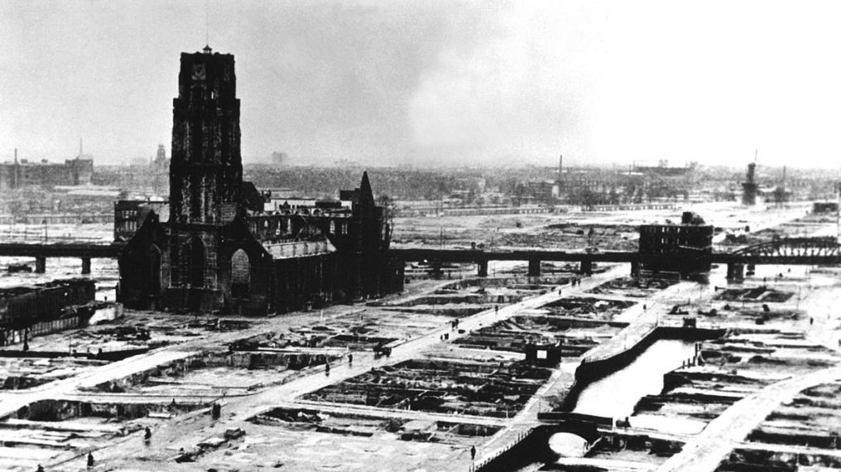
Rotterdam after the German blitz (Public Domain/Wikimedia Commons)

Whereas the Franks, a family of secular and cosmopolitan Jews from Germany, lived apart from the people who hid them, the Ulreichs lived with the Zijlmans in conditions that required considerable sacrifice on the part of the hosts and led to some friction as the two households interacted.
‘They will come with their truck, and we’ll have to go to Westerbork and then to Poland and after that… death?’
The Zijlmans couple, who were recognized by Israel as Righteous Among the Nations in 1977 for risking their lives to save the Ulreichs, gave their bedroom to the Ulreichs and moved into a small room where potatoes were stored. They also severed their social contacts to avoid detection as their guests lived in fear.
“We are simply terrified that they will report us to the Waffen-SS for neighborhood disturbance,” Ulreich wrote of the neighbors. “Then they will come with their truck, and we’ll have to go to Westerbork and then to Poland and after that… death?”
Westerbork was a Nazi transit camp in Holland’s northeast.
Ulreich also recalls hearing a chazan, or cantor, offer a prayer for Holocaust victims on a British radio transmission, which she said made the Jews cry and feel “connected with him by heart.” But she complains over the airing of the prayer on Shabbat, when Jews are not supposed to turn on the radio.
“The Christians try to support us, but they simply don’t understand these things,” she wrote.
“Carry shows, next to the enormous gratitude for the hospitality, the discomfort of two different families who suddenly have to live together,” wrote Bart Wallet, the editor of the diary and expert on Dutch Jewry with the Vrije Universiteit Amsterdam. “The tension and complete dependence are almost tangible for the reader.”
The diary also describes theological discussions between the families.
“This book reveals a lot of information about a, until now, highly undiscussed topic: the religious life in hiding,” Wallet wrote. “It shows how the Jews struggled to eat kosher and how they still tried to celebrate their holy days.”

Reprinted from the October 14, 2016 email of The Times of Israel.

From Rome to Israel
By Rabbi Benzion Klatzko

כי חלק ד׳ עמו For Hashem’s portion is His people (Devarim 32:9)

When Cory Carbon, a young irreligious boy living in Florida, was in twelfth grade, his graduating class planned the very exciting trip to Rome. Anticipating an exhilarating experience including breathtaking sights and adventures, Cory looked forward to having a wonderful time.
It was finally when they arrived in Rome and were one day being driven around that the bus driver, who as well served as the students’ tour guide, announced over the loud speaker, “Are any students in this class Jewish?”
Almost viscerally, Cory’s hand went up.
“Please get off the bus,” said the bus driver over the loud speaker.
Unsure why he would be asked to leave, Cory began wondering what he had done to warrant such specialized treatment. Respectfully following instructions, Cory walked off the bus.
Second-guessing if he should have ever raised his hand in the first place, Cory was soon surprisingly approached by the bus driver. “What is your name?” gently probed the driver.
“Cory.”
And with that, the bus driver began to explain. “Let me tell you why I told you to get off the bus. We have reached the Arch of Titus. Built as a source of pride to the Romans, the images of Jewish artifacts engraved upon the Arch were fashioned to denigrate and shame your people.
“You should know,” continued the driver, “that in 1948, when the Jewish people resettled Israel, a number of Jews traveled to Rome and walked under the Archway holding candles. Triumphantly showing that the nation of Israel had persevered the toughest of conditions, the throng of Jews broke out joyously singing, ‘Am Yisrael Chai!’”
Prodding Cory to walk through the Archway and himself repeat those eternal words, the bus driver reassured him that the bus would wait. And so, Cory walked through the Arch of Titus a bit awkwardly, yet also jubilantly.
Next year… Cory decided he would sign up for a student trip to Israel. Researching the matter, he came across a group trip called Akiva. An organization which I myself am a part of and help run, numerous applications were sent in from students vying for the positions. That year, included among the many applicants was Cory.
Unfortunately, however, Cory’s application slipped through the cracks and was never examined. Two weeks before the trip, there were a few more openings available. Asking my secretary to look through all the names of those who had applied and see who we had accepted, it was discovered that we had in fact overlooked Cory Carbon. He had an unopened application. Looking through his background information, I could immediately tell that he was a special boy. Tremendously moved by what he had to say about himself, I called him on the spot. And he picked up right away. Introducing myself as Rabbi Klatzko from the Akiva trip, I could tell that at the moment he was somewhere where there was much surrounding noise.
After speaking to him at length, I said, “Even though it is only two weeks before the trip, I hope you don’t have any other plans and have a valid passport. You are going to Israel!” Profusely thanking me, as I hung up, I could tell that he was very appreciative and that he would have a great time.
Little did I know what was going on at the other end of the line and the underlying reason for the raucous background noise. Cory belonged to a fraternity and was at the time attending an event. It was amid the hustle and bustle of this party that he received my phone call.
Caught off guard and a bit embarrassed by the uniform the fraternity group was wearing – brass skirts and flowered lays – he stepped outside for a moment by himself. And then he heard the great news he was tremendously anticipating. Without thinking twice, he broke out dancing.
He could only wonder how the upcoming trip to Israel would teach him about his Jewish heritage and enhance his appreciation of Judaism. Catching sight of Cory dancing was another boy. Approaching Cory, the boy introduced himself and mentioned that he was also Jewish. Happy to hear that a fellow Jew was in the area, Cory grabbed him by the hand and continued dancing and chanting, “Am Yisrael Chai!” The scene almost mirrored Cory’s experience in Rome where he had also celebrated his Jewish identity.
When Cory later arrived in Israel and visited the Kotel, he was emotionally energized. Looking at the Wall which represents the solidarity of the Jewish people and forever has been and will be a source of hope and dreams, Cory stood there in awe. Proceeding to pour his heart out to Hashem, as Cory finished off his prayers, he came up with a great idea.
Turning on his phone, he called his mother. “I know how you have always told me that you wish you could pray at the Western Wall,” Cory said to his mother. “Now, you have five whole minutes to do so.” Picking up his cellphone against the Kotel, his mother offered her sincerest prayers to Hashem. After five minutes, his mother was sobbing.
But Cory did not stop there. Calling his grandmother, Cory did the same as he did for his mother. Holding up the phone opposite the Kotel for five consecutive minutes, his grandmother went on to pray for the first time in many years.
Never should we underestimate the effect even a small dose of exposure to spirituality can accomplish. Its impact can be endless and travel long distances. For Cory, his upward spiritual climb began when he started to recognize the beauty of Yiddishkeit and make the decision to take one step forward. All it takes is the earnestness and excitement to realize the meaning of Torah and Judaism and yearn to grow more and learn more. Once that is so, the places such love and yearning can take us are far beyond our furthest dreams. It brings us closer to Hashem, along with our families and friends all across the globe.

Reprinted from the Parshas Ha’Azinu 5777 email of TorahAnyTimes.

Mesiras Nefesh in a
Russian Labor Camp

Rabbi Paysach Krohn describes how when Rav Tuvya Goldstien and his friends were young, they were ready to sacrifice their lives for Shabbos. The story takes place in a Russian labor camp, in 1943.
Rav Tuvya and some Yeshivah Bachurim were imprisoned in the camp, and were forced to work even on Shabbos. Their job was to take chopped tree trunks and branches and carry them to a nearby river. One Shabbos afternoon, the supervisor brought the group to the work area, and told them that he would return in three hours to check on their progress.
The Bachurim thought they would be left unobserved, but the supervisor went to the top of a nearby hill and secretly watched them, and what he saw made him very angry. Rav Tuvya and his friends felt that if they had to work on Shabbos, they should at least minimize the Chilul Shabbos as much as possible. They therefore decided to implement two Halachic concepts.
One, if two people carry an item that is usually carried by one person, it is a Rabbinic violation, not a Torah violation, and second, carrying less than four Amos at a time. This too is an Aveirah M’DiRabbanan, not a D’Oraysa. All afternoon, Rav Tuvya and his friends carried all the small twigs in this manner, two people holding them, walking three Amos at a time until they got to the river.
The supervisor was furious and he put them all on trial, accusing them of sabotaging their war efforts against the enemy. When one of the Bachurim tried to defend their actions on religious grounds, the judges did not believe them, and called them traitors and spies, and they were taken to jail. Rav Tuvya and the boys decided to say Viduy, believing they would not live to see the next day.
As the judges took turns lecturing their audience about the great war efforts of the Soviet Union, they suddenly stood up as a group of six men from the Moscow Interior Central Committee entered the room. They usually came once a year to check on the conditions of the laborers, but there was no purpose for them to come at night, as no one worked at night. Why were they here now?
The presiding judge, seeking to make a favorable impression on his superiors, had the supervisor repeat his argument that the Bachurim were traitors, and the Moscow officials seemed to be pleased, except for one, who stared ahead without emotion.
He asked permission to speak with the boys privately. When the Bachurim entered the room with the official, they stood stiffly at attention, not knowing what to expect.
The officer said, “Gut Voch”, and then reassured them that he was a Yid. The boys immediately tried to explain their story as best as they could, and then the officer told them his story.
“I am a Jew, but I am also a Communist. Before my mother died, she told me that she wanted to be able to die in peace, and made me promise that someday I will help a religious Jew. I believe that now is the time to fulfill my promise, because it was a power beyond my control that brought me here to you. We never come to these camps after dark, but tonight, our car broke down on a nearby road. We had no idea where we could stay overnight, until we saw the lights of this auditorium. We walked over here, right in the middle of your trial.”
He told the boys, “When we return to them, let me speak on your behalf. I will take care of you.” When they returned, the officer addressed the judge, “You insist that these people are traitors, but how have they been working until now?” The supervisor quietly said, “Until now they have been loyal.” The officer glared at him and the supervisor added, “I don't know what happened to them today. In fact, just this past Thursday night they were the only ones who volunteered to help with a late-night delivery of heavy chains.”
The officer said, “It is my impression that these boys are extremely loyal in our fight against the enemy. It’s obvious that just today they changed their work habits because of this religion of theirs. It is also my impression, just by looking at them, that these workers are not being given the amount of food that they need. How can they produce effectively when they are only given meager portions? Their rations must be increased, and then they will be able to work even better!” The case was dismissed and no punishments were given out! Rav Tuvya finished this story and said, smiling with pleasure, “I lived through a miracle in which we were saved from imminent danger and saw the hidden hand of Hashem revealed! It was nothing short of an outright miracle!”

Reprinted from the Parshas Ha’Azinu 5777 email of Torah U’Tefilah: A Collection of Inspiring Insights compiled by Rabbi Yehuda Winzelberg.

Thoughts that Count

After the Fair

It was the custom of most merchants years ago to obtain their goods by periodically attending a great fair where all kinds of merchandise were sold wholesale and in bulk. The merchants would take the large packages home, sort through the contents and then use them as they saw fit. The month of Tishrei is similar to such a wholesale fair, during which we obtain huge portions of holiness and joy in doing mitzvot--enough to last us the whole year. The only condition is that we actually open the bundles and use their contents. These bundles are opened up and used for the first time on Shabbat Bereishit. (Lubavitcher Rebbe)

In the beginning G-d created (Gen. 1:1)
The final letters of the Hebrew words "G-d created"--"bara elokim et"--are alef, mem, and tav, and spell the word "emet"--truth. Truth is the foundation upon which the whole world stands, and without which the entire creation would be unable to exist. (Tzror Hamor)

G-d rested from all the work which He had created to be done. (2:3)
Rashi explains that the words "to be done" teach that the world was created incomplete, as it were, requiring the active participation of mankind to attain perfection. But how can we, insignificant as we are, complete the act of creation? The Torah's own words, "created to be done" assures us that this perfection is within our grasp, and is part of G-d's plan. Each of us has the strengths and talents to improve the world and elevate it into something holy and Divine.(Lubavitcher Rebbe)

Reprinted from the Parshas Braishis 5753/1992 edition of L’Chaim Weekly.

